**MONISHA.DUSANAPUDI**

**Phase 4 Report: Process Automation**

**Non-Profit Donation & Volunteer Management**

**Objective:** The primary objective of Phase 4 was to layer intelligence and efficiency onto the data model by implementing a suite of automations. The focus was on using Salesforce's modern, consolidated automation tool, Flow Builder, to enforce business rules, streamline repetitive tasks, and improve the end-user experience. Each automation was rigorously tested to ensure its functionality and reliability.

**Validation Rules: Enforcing Data Integrity**

* **Automation Implemented:** A validation rule named Donation_Amount_Must_Be_Positive was created on the Opportunity (Donation) object.
* **Business Logic:** This rule fires before a record is saved and utilizes the formula Amount <= 0. If this condition is true, the rule prevents the record from being saved and displays a custom error message to the user.

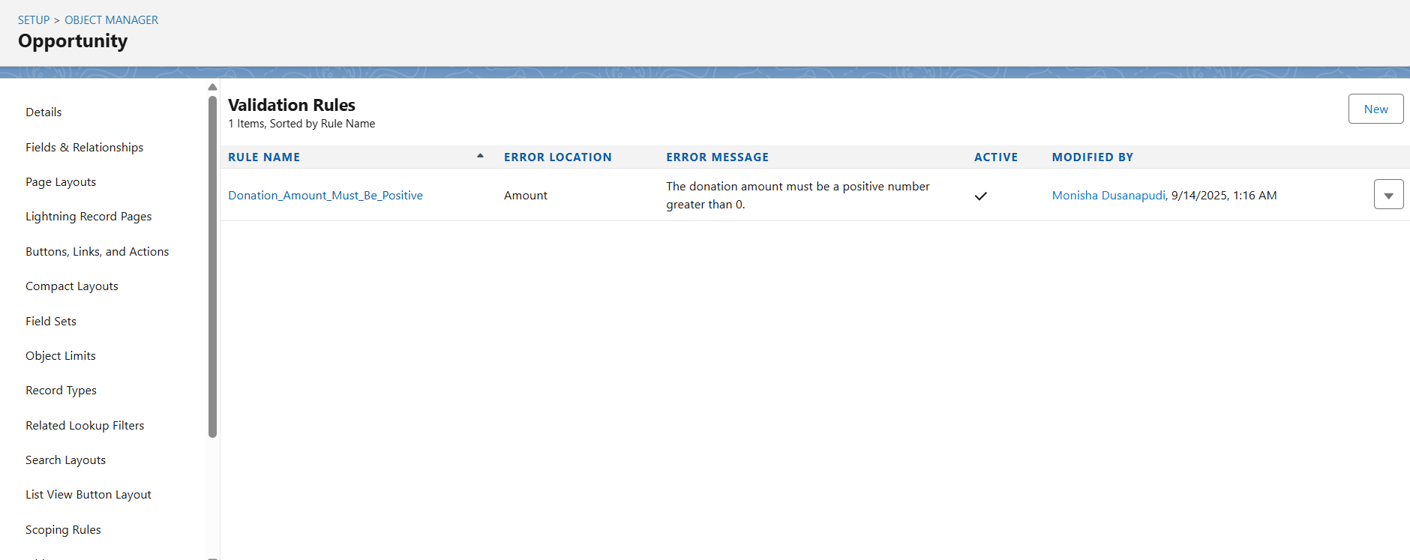

* **Testing & Verification:**
  + **Test Case:** A new Opportunity record was created. The Amount field was intentionally set to 0, and all other required fields were filled in correctly.
  + **Execution:** An attempt was made to save the record.
  + **Result:** The test was **successful**. The system correctly blocked the save operation and displayed the custom error message: "The donation amount must be a positive number greater than 0." This confirms the rule is working as designed.

**Record-Triggered Flow: Automating Donor Communications (this includes email alerts)**

* **Automation Implemented:** A record-triggered flow named Donation - Send Thank You Email was built. This modern automation replaces the need for legacy tools like Workflow Rules or Process Builder.
* **Business Logic:** The flow is configured to trigger automatically only when an Opportunity record is updated and its Stage field is set to Posted. When triggered, it executes a "Send Email" action, sending a personalized thank-you note to the primary donor's (Contact) email address. The email body dynamically merges in the donor's first name and the specific donation amount using merge fields.

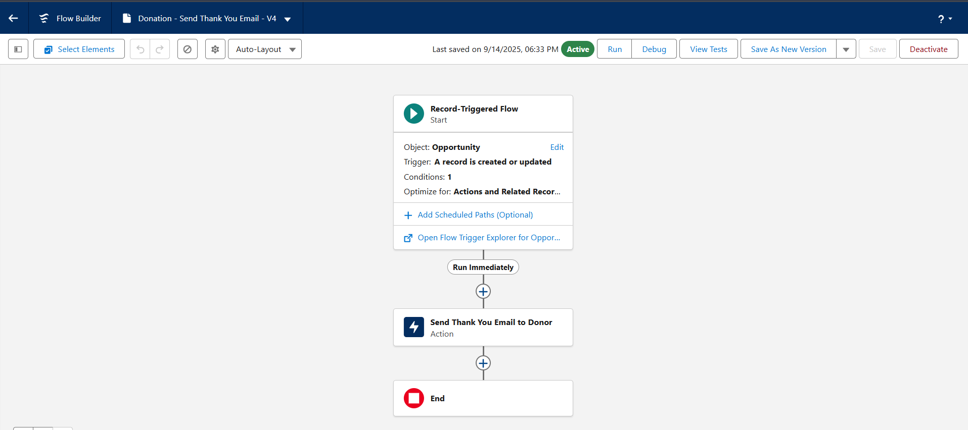

* **Testing & Verification:**
  + **Test Case:** A test Contact ("Susan Volunteer") was updated with a real, accessible email address. A new Opportunity record was created and linked to this contact, with the initial Stage set to Pledged.
  + **Execution:** The Opportunity record was then edited, and its Stage was changed from Pledged to Posted.
  + **Result:** The test was **successful**. Within moments, an email was received in the designated inbox. The email had the correct subject line, and the body was correctly personalized with the donor's name and the donation amount. Initial tests revealed a formatting issue (displaying HTML tags), which was successfully troubleshooted by reconfiguring the flow to use the "Rich-Text-Formatted Body" input, demonstrating a complete development and debugging cycle.

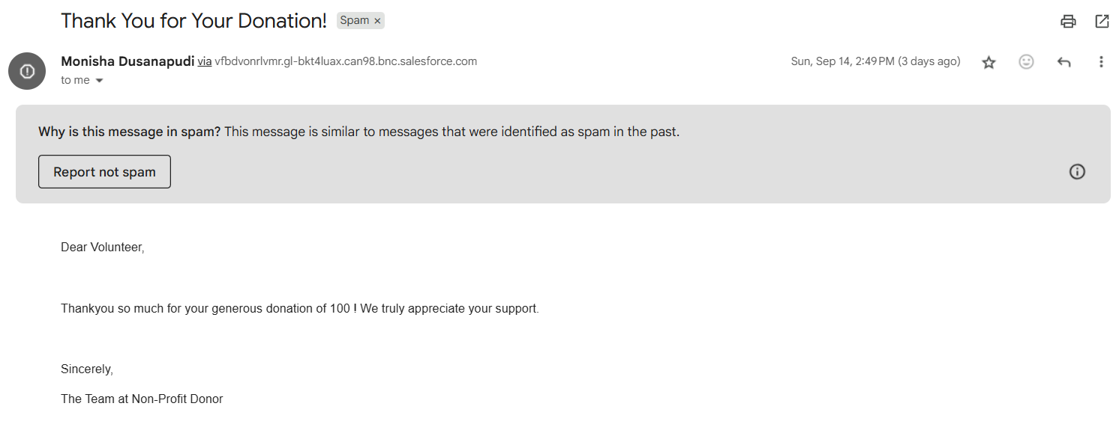

**Screen Flow: Guiding the User Experience**

* **Automation Implemented:** A screen flow named Volunteer Event Sign-Up was built to provide a guided, wizard-style interface for a key business process.
* **Business Logic:** The flow presents the user with a single, clean screen containing two lookup fields: one to search for an existing Contact (Volunteer) and another to search for an Event. Upon the user making their selections and clicking "Finish," the flow's logic proceeds to a "Create Records" element in the background. This element automatically creates a new Volunteer Hours junction object record, correctly linking the selected volunteer to the selected event.

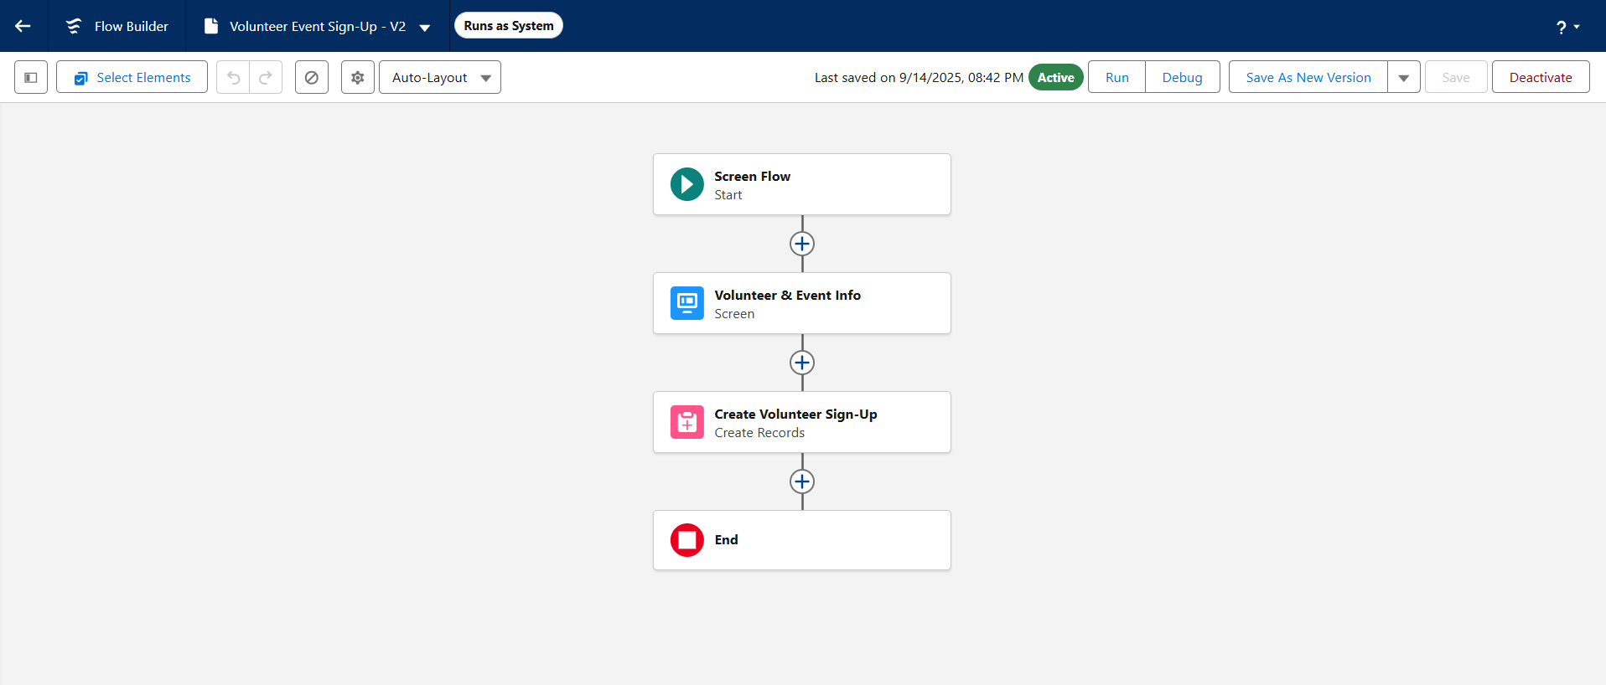

* **Testing & Verification:**
  + **Test Case:** The flow needed to create a new sign-up record between an existing volunteer and an existing event.
  + **Execution:** The flow was run directly from the Flow Builder's "Run" feature. The test Contact ("Susan Volunteer") and test Event ("Annual Charity Gala") were selected on the screen. The "Finish" button was clicked.
  + **Result:** The test was **successful**. Post-execution, verification was performed by navigating to both the "Susan Volunteer" Contact record and the "Annual Charity Gala" Event record. The "Related" tab on both records correctly displayed a new Volunteer Hours record, proving that the flow successfully created the relationship and is functioning as designed.

**Conclusion:** Phase 4 has been successfully completed and rigorously tested. The implementation of a validation rule, a record-triggered flow, and a screen flow has layered significant intelligence and efficiency onto the data model. The application can now enforce data quality, automate critical communications, and guide users through complex tasks, making it a powerful and reliable tool for the non-profit.